|  |  |
| --- | --- |
| No. of Pages | 3 |
| No. of Questions | 7 |

**Student Name: ________________________________ID:____________________**

**Department of Computer Science and Engineering**

**Midterm Examination FALL 2015**

**CSE420: Compiler Design**

**Total Marks: 40 Time Allowed: 1 Hour**

|  |
| --- |
| * You HAVE TO RETURN this question paper and the answer script at the end of the exam. Your script will not be checked unless you do so. * You are not allowed to communicate with any other candidate in any way what so ever. |

**Section A (There are 2 questions, answer any 1 out of them) [4*1=4]**

1. a) What Factors Have Influenced the Functional Division Lexical analyzer and Syntax analyzer? [2]

b) Define Handle Pruning. [2]

2. a) Define Buffer Pairs. [2]

b) Provide some insights on “LL vs. LR”. [2]

**Section B (There are 3 questions, answer any 2 out of them) [10*2=20]**

1. a) Convert following NFA to DFA using **subset construction methodology**. [10]

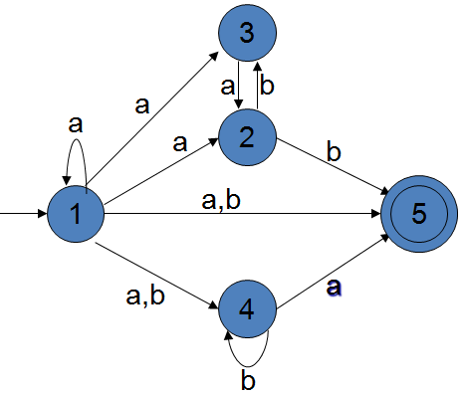

1. Convert RE ***((ab)|(ba))\**** to corresponding DFA (using first-pos, last-pos and follow-pos). [10]
2. Construct a table-based LL(1) predictive parser of following grammar:

*S -> UVW*

*U -> (S)|aSb|d*

*V -> aV| ϵ*

*V -> cW| ϵ*

Give the parsing actions for the input string “(dc)ac”. [7+4]

**Section C**

1. Consider the following grammar.

*S -> Aa*

*S -> bAc*

*S -> Bc*

*S -> bBa*

*A -> d*

*B -> d*

1. Compute the LR(0) automation for the grammar. [6]
2. Construct the LR(0) parsing table. [6]

2. **Parse** input string “***baab*”** using following resources: [4]

